**VICTORIOUS PRIMARY SCHOOL**

**PRIMARY ONE MATH LESSON NOTES TERM III 2018**

**WEEK: TWO**

**THEME: TRANSPORT**

**SUBTHEME: TYPES OF TRANSPORT**

**CONTENT: ADDING FRACTIONS**

[a] 2/15 + 4/15 [b] 6/20 + 7/20

[c] 1/9 + 3/9 [d]3/10 + 4/10

**Reference**

**Mk Mathematics 2000 bk 1 g 83**

**Understanding MTC bk 1 pg 65**

**WEEK: TWO**

**THEME: TRANSPORT**

**SUBTHEME: TYPES OF TRANSPORT**

**CONTENT: SUBTRACTING FRACTIONS**

6/9 – 1/9 = 4/5 – 3/5 = 10/20 – 5/20

9/15 – 3/15 6/8 – 2/8 5/9 – 6/9

10/15 – 6/15 10/15 – 12/15 9/30 – 9/30

**Reference**

**MK primary mathematics 2000**

**Understanding mathematics book 1 pg 65**

**WEEK: TWO**

**THEME: TRANSPORT**

**SUBTHEME: TYPES OF TRANSPORT**

**CONTENT: LINES AND CURVES**

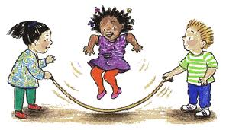

**Curve**

**Line**

**Activity**

Name the curves and lines (photocopied work)

**Reference**

**Pri MTC bk 1 pg 92**

**Under MTC bk 1 pg 72 – 73**

**Rimary MTC bk1 Trs gd bk pg 87**

**(photocopied work)**

**WEEK: TWO**

**THEME: TRANSPORT**

**SUBTHEME: GEOMETRY**

**CONTENT: FACES, EDGES AND VERTICES** face

Vertex face vertex

face

edge

**Activity**

Name the faces, edges and vertices

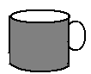

Photocopied work page 93

**Reference**

**MK Pri MTC bk 1 pg 93**

**Pri MTC bk1 pg 62**

**Und. MTC bk1 pg 73.**

**WEEK: TWO**

**THEME: TRANSPORT**

**SUBTHEME: MEASURES**

**CONTENT: TELLING TIME TO THE HOUR**

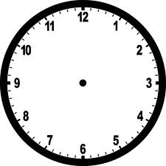

3 O’clock 7 O’clock

**Activity 1**

1. Practical work on the clock face.

2. Tell the time on the clock face



**Activity II**

Indicate the time on the clock face



3 O’clock 6 O’clock 4 O’clock

**Reference**

**Mk Pri MTC bk 1 pg 104**

**PPrimary School MTC bk 1 pg 68**

**WEEK: TWO**

**THEME: TRANSPORT**

**SUBTHEME: MEASURES**

**CONTENT: TELLING TIME**



**Activity 1**

Tell the time on the clock face.

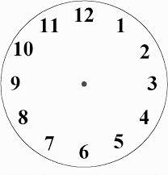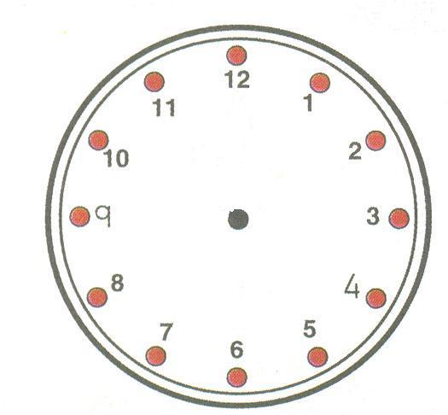

**Activity II**

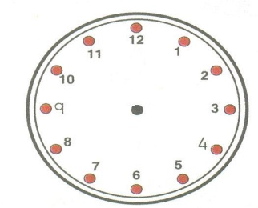**Draw the clock faces.**



It is five(5) O’clock It is 3 O’clock

**Reference**

**Mk primary MTC bk 1 pg 104**

**Mk Tr’s guide bk 1 pg 110**

**WEEK: TWO**

**THEME: TRANSPORT**

**SUBTHEME: ORDINAL NUMBERS**

**CONTENT: WRITING ORDINAL NUMBERS**

**(PHOTOCOPIED WORK)**

1st First

**Tom**

**Jane**

**Rose**

2nd Second

3rd Third

4th Fourth

**Jacky**

**Pater**

5th Fifth

6th Sixth l

**Ronny**

7th Seventh

8th Eighth

**Paul**

**Tina**

**Mercy**

9th Ninth

**Sarah**

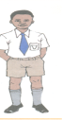10th Tenth

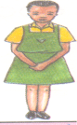

Sarah Mercy Tina Ronny Paul Peter Jacky Rose Jane Tom

1st 2nd 3rd 4th 5th 6th 7th 8th 9th 10th

**Activity**

1. Who is the fourth?

2. In which position is Mercy?

3. Who was the eighth?

4. Who is the tenth?

5. Write the ordinal number for

2\_\_\_\_\_\_\_\_ 3\_\_\_\_\_\_\_ 5\_\_\_\_\_\_\_ 1\_\_\_\_\_ 7\_\_\_\_

Write these ordinal numbers in words

1st\_\_\_\_\_\_\_\_\_\_\_\_\_ 2nd \_\_\_\_\_\_\_\_\_\_\_\_ 4th \_\_\_\_\_\_\_\_\_\_\_\_\_\_

**Reference**

**MK primary MTC 2000 bk 1 pg 74 – 76**

**NPSC for Ug pg 339**

**WEEK: THREE**

**THEME: TRANSPORT**

**SUBTHEME: COMPARING**

**CONTENT: MEASURING LENGTH, WIDTH, HEIGHT.**

A

B

Length is how long or short something is.

a) Which stick is shorter? Stick A is shorter.

b) Which stick is longer? Stick B is longer.

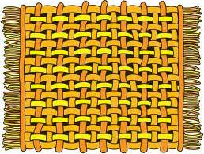 A

P

 B

Q

Which ruler is longer? Which Scarf is longer?

Which ruler is shorter? Which scarf is shorter?

**Reference**

**Pri MTC Tr’s guide pg 93**

**WEEK: THREE**

**THEME: TRANSPORT**

**SUBTHEME: COMPARING OBJECTS**

**CONTENT: MEASURING WEIGHT.**

Weight is how light or heavy something is.



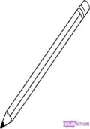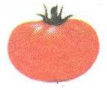

Stone

Pineapple Orange Pencil

Which one is heavier? Which is heavier?

Which one is lighter? Which is lighter?

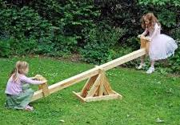**Activity**

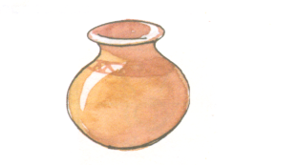Compare the weight. Who is lighter?

Who is heavier? SL01040_

Pot ball

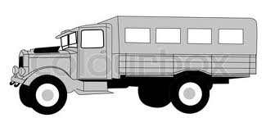 Lorry car

**Which one is smaller?**

**Which one is bigger?**

**Which one is smaller?**

**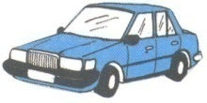Which one is bigger?**

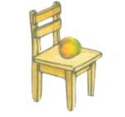

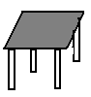

Table chair

**Reference**

**Mk Pri MTC 2000 bk 1 pg 102 – 104**

**Under MTC bk 1 pg 115**

**Mk Pri MTC bk 1**

**Nelson MTC bk1 pg 24**

**Lets learn mathematics ppls bk1 pg 63,64,66,68,125,127,129**

**WEEK: THREE**

**THEME: TRANSPORT**

**SUBTHEME: MEASURES**

**CONTENT: COMPARING HEIGHT**

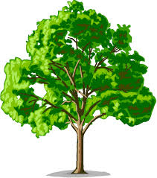Height is how tall or short something is.

1. Which tree is taller? Tree C is taller.

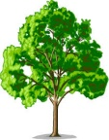 2. Which tree is shorter? Tree D is shorter.

3. Tree D is \_\_\_\_\_\_\_\_ than tree C.

4. Tree C is \_\_\_\_\_\_\_ than tree D.

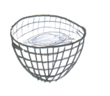

 C D

**Activity**

Compare the heights

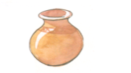1. Which is taller?

Sarah Mercy

\_\_\_\_ is shorter than\_\_\_\_

The pot is \_\_\_ than the basket.

Which is shorter?

\_\_\_ is taller than \_\_\_ Sarah is \_\_\_\_\_ than Mercy.

Which house is shorter? Who is taller?

Which house is taller? \_\_\_\_\_\_\_\_\_ is shorter.

Pics 016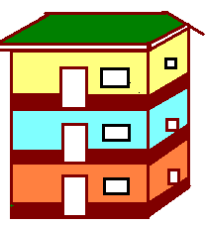

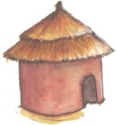

A flat A hut Tom Jim

**Reference:**

**MK Pri MTC 2000 bk 1 pg 102 – 104**

**Lets learn MTC pgs 64, 66, 68**

**WEEK: THREE**

**THEME: TRANSPORT**

**SUBTHEME: MEASURES**

**CONTENT: COMPARING CAPACITY**

Capacity is the measure of how much an object can hold.

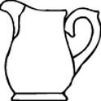 jug 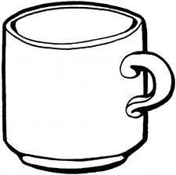mug

1. Which container holds more? 2. Which container holds less?

3. How many glasses of water can fill the jug? (Practical lesson)

**Use less or more**

a. The glass holds \_\_\_\_\_\_\_ water than the jug.

b. The jug holds \_\_\_\_\_\_\_\_ water than the glass.

**Activity**

Compare the capacity.

1. Which container holds more?

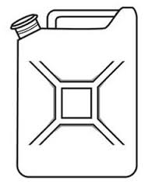 jerry can jug

**Reference:**

**Mk Prim MTC 2000 bk 1 g 102 – 104**

**Und. MTC bk 1 pg 113**

**MK Pri MTC bk1 pg 94 Trs gd**

**Nelson MTC bk 1 pg 24**

**WEEK: THREE**

**THEME: TRANSPORT**

**SUBTHEME: MEASURES**

**CONTENT: AREA**

Area is the surface or space covered by an object.

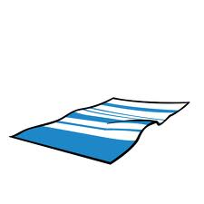When finding area we measure the top part of an object.

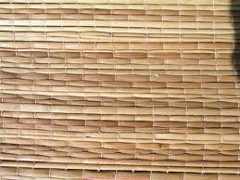

**hankie**

**Table cloth**

mat

The mat covers a bigger area than the hankie.

**Activity**



a b c d e f g h f I h

ffff hh h

A mat

A chart

The \_\_\_\_\_ covers a bigger part than the \_\_\_\_\_\_\_\_\_\_\_\_

**Reference**

**A New Pri MTC trs guide pg 98**

**A New Pri MTC bk1 pg 105**

**Und MTC bk1 pg 117**

**Mk Pri 2000 bk 1 pg 105**

**WEEK: THREE**

**THEME: TRANSPORT**

**SUBTHEME: MEASURES**

**CONTENT: MONEY**

Our money (Ugandan currency)

**Activity**

1. Draw and name. (Tracing money coins)

\_\_\_\_Shillings coin \_\_\_\_\_Shillings coin \_\_\_\_\_Shillings coin

\_\_\_\_Shillings coin \_\_\_\_\_\_ shilling notes.

**Reference:**

**MK Pri MTCs 2000 bk 1 pg 94**

**Under MTCs bk1 pg 105**

**Lets learn math bk1 pg 110 – 111**

**Improve your MTC std I work book pg 65 – 66**

**Activity**

1. Filling in the missing money.

Shs\_\_\_\_\_ + Shs\_\_\_\_\_ Shs \_\_\_\_\_+ \_\_\_\_\_Shs

**Reference**

**Mk Pri MTC 2000 bk 1 pg 92 – 98**

**Und MTCs bk1 pg 74 – 75 (photocopied)**

**Improve your MTC std 1**

**WEEK: FOUR**

**THEME: THINGS WE MAKE**

**SUBTHEME: MEASURES**

**CONTENT: HOW MUCH (MONEY) ADDITION HORIZONTALLY**

shs100 + sh 200 = sh 300

shs100 + shs100 = sh 200

shs50 + shs50 = sh 100

**Activity**

Shs 50 + shs 50 = shs\_\_\_\_ shs 100 + shs 100 = shs\_\_\_\_\_

Shs 100 + shs 200 = shs \_\_\_\_ shs100 + shs 400 = shs \_\_\_\_\_

Shs 200 + shs 200 = shs\_\_\_\_ shs 600 + shs 100 = shs \_\_\_\_\_

Shs 500 + shs 200 = shs \_\_\_\_ shs 200 + shs 300 = shs\_\_\_\_

**LESSON III**

Adding money vertically

1. sh 50 2. Sh 100 3. Mary has sh 100

+Sh 50 +sh. 50 +sh 100

Sh sh

**Activity:**

Add the money

1. shs 300 2. Shs 200 3. Shs 100

+Shs 100 +shs. 50 +shs 100

Shs shs shs

1. shs 300 2. Shs 200 3. Shs 100

+Shs 100 +shs 50 +shs 100

Shs shs shs

1. shs 50 2.Tom has Shs 300

+Shs 50 +shs. 100

Shs Shs

**Reference**

**Mk Primary Math 2000 book 1 pg 96 – 97**

**Lets learn mathematics book 1 pg 110**

**WEEK: THINGS WE MAKE**

**SUBTHEME: MEASURES**

**CONTENT: SHOPPING USING A PRICE LIST IN THE SUPERMARKET**

milk shs 500 book shs 500 mango – Shs. 200

sweet – Shs. 100

book - Shs. 500

cake orange – Shs.400

200/= egg - Shs. 100

rubber - Shs. 100

Example

1. How much money does an egg cost?

2. Two books cost \_\_\_\_\_\_\_ shillings. **Mk primary MTC 2000 bk 1**

500/= + 500/= = 1000/= **photocopied work page 98**

**Activity**

Answer the questions using the price list aboe.

a) A mango costs \_\_\_\_\_\_\_\_\_ shillings

b) Two rubbers cost \_\_\_\_\_\_\_\_ shillings.

c) How much does a cake cost?

d) Milk costs \_\_\_\_\_\_\_ shillings.

e) What is the cost of a book and a mango.

a book cost sh\_\_\_\_\_

a mango cost sh\_\_\_\_

Total sh\_\_\_\_\_\_

**Activity 1**

Fill in using the price list

**(photocopied work) Mk primary MTC 2000 book 1 pg 97**

a) A biscuit costs \_\_\_\_\_\_\_ shillings

b) \_\_\_\_\_\_\_\_\_ costs 500/=

c) A pen costs \_\_\_\_\_\_ and omo costs \_\_\_\_\_

d) Omo costs 200/=

A book costs 100/=They both cost \_\_\_\_\_

**Reference:**

**Mk Primary Mathematics book 1 pg 97**

**Under MTC book 1 pg 77**

**Mk Pri MTC 2000 book 1 pg 92 – 98**

**Primary MTCs book 1 page 92 – 96**

**WEEK:**

**THEME: OUR ENVIRONMENT**

**SUBTHEME: MEASURES**

**CONTENT: SUBTRACTION OF MONEY**

a) Shs. 200 – shs 100= \_\_\_\_\_\_ Shs. 400 Shs. 200

b) Shs. 300 – shs 200 = \_\_\_\_\_ - Shs. 200 - Shs. 100

c) Shs. 100 – shs 50 = \_\_\_\_\_

**Activity**

Subtraction of money

Shs. 50 – shs. 30 = \_\_\_\_\_ Shs. 50 – shs. 50 = \_\_\_\_\_\_

Shs. 200 – Shs. 100 = \_\_\_ Shs. 500 – Shs. 300= \_\_\_\_\_

**Activity II**

Shs. 500 Shs. 70 Shs. 100 Shs. 800

Shs. 200 - Shs. 40 - Shs. 100 - Shs. 400

Shs. Shs. Shs. Shs.

**Reference:**

**Primary MTC book 1 pg 96**

**Understanding MTC book 1 pg 75**

**WEEK:**

**THEME: OUR ENVIRONMENT**

**SUBTHEME: NUMERATION SYSTEM AND PLACE VALUES**

**CONTENT: WRITING NUMBER WORDS FROM 50 – 100**

50 – fifty 51 – fifty one 52 – fifty two 53 – fifty three

55 – fifty five 60 – sixty 61 – sixty one 70 – seventy

80 – eighty 82 – eighty two 100 – one hundred

**Activity**

1. Write in figures

fifty \_\_\_\_\_\_\_\_\_\_\_ twenty\_\_\_\_\_\_\_\_\_ forty one\_\_\_\_\_\_\_\_

sixty \_\_\_\_\_\_\_\_\_\_ eighty five\_\_\_\_\_\_\_ seventy nine\_\_\_\_\_

One hundred \_\_\_\_\_\_\_\_\_\_\_

**Activity II**

Write in words

70= \_\_\_\_\_ 40=\_\_\_\_\_\_ 92= \_\_\_\_\_ 71=\_\_\_\_\_\_\_

51 = \_\_\_\_ 10 = \_\_\_\_\_ 84 = \_\_\_\_\_ 77 = \_\_\_\_\_\_

99 = \_\_\_\_ 100 = \_\_\_\_ 63 = \_\_\_\_\_ 63= \_\_\_\_\_\_\_

**Reference:**

**Mk Primary Mathematics 2000 book 1 pg 76 – 77**

**Mk Teachers guide book 1 pg 105**

**WEEK:**

**THEME: OUR ENVIRONMENT**

**SUBTHEME: NUMERATION SYSTEM AND PLACE VALUE**

**CONTENT: MISSING NUMBERS IN ADDITION**

+ 1 = 4 + 4 = 6 5 + = =10

+ 5 = 8 + 6 = 7 + 6 = 9

**Activity**

Fill in missing numbers

+ 4 = 9 5 + = = 9 3 + = = 12 + 1 = 8

+ 6 = 6 6 + = 10 2 + = 0+ = 3

**Reference:**

**Understanding mathematics primary 1 pg 91**

**Lets learn mathematics pupils book one page 93**

**WEEK:**

**THEME: OUR ENVIRONMENT**

**SUBTHEME: ALGEBRA**

**CONTENT: MORE ON MISSING NUMBERS WITH ADDITION.**

**Examples**

1. Three plus five equals eight

2. Two plus three gives us five

3. Eight plus two equals ten.

**Activity**

1. One plus equals twelve.

2. Five plus equals eight.

3. six plus gives nine.

4. 7 plus equals 10.

**WEEK:**

**THEME: OUR ENVIRONMENT**

**SUBTHEME: OPERATION ON NUMBERS**

**CONTENT: DIVISION / SHARING**

Example

Peace and security

2 ÷ 2 = 1

6 ÷ 2 = 3

Activity

4 ÷ 2 = \_\_\_\_\_\_\_

8 ÷ 2 =

9 ÷ 3 = \_\_\_\_\_\_\_

3 ÷ 3 = \_\_\_\_\_\_\_

Share 6 sweet between 2 girls \_\_\_\_\_\_\_\_\_\_\_\_\_\_\_\_\_\_\_\_

**Reference:**

**Mk Prim. Mathematics Book 1 Pg. 122**

**WEEK:**

**THEME: PEACE AND SECURITY**

**SUBTHEME: REVIEW**

**CONTENT: VERTICAL AND HORIZONTAL SUBTRACTION**

**Examples**

5 – 3 = 2 12 – 6 = 9 – 3 =

5 10 8 9

- 1 - 2 - 4 - 9

**Activity**

12 – 6 = 9 – 3 = 16 – 4 =

5 6 8 7

- 3 - 3 - 4 - 3

**Activity II**

Tens Ones Tens Ones Tens Ones

3 4 7 4 6 5

- 1 2 - 3 2 - 1 2

Tens Ones Tens Ones Tens Ones

1 0 4 4 5 5

- 1 0 - 1 1 - 3 2

**Reference:**

**Mk primary MTC book 1 pg 73**

**Integrated MTC book 1 pg 52**

**Primary MTC book 1 pg 66**

**WEEK:**

**THEME: PEACE AND SECURITY**

**SUBTHEME: REVIEW**

**CONTENT: ADDITION OF FRACTIONS**

**Examples**

**½ + ½ = 2/2 2/4 + ¼ = ¾ 1/3 + 1/3 + 1/3 = 3/3**

**Activity**

**1/5 + 2/5 = 2/5 + 1/5 + 1/5 = 2/7 + 3/7 =**

**4/10 + 6/10= 3/9 + 3/9 4/8 + 1/8=**

**Reference:**

**Mk Primary MTC 2000 bk 1 pg 81 – 84**

**Understanding MTC book 1 pg 92**

**Practice Number skills page 2**

**WEEK:**

**THEME: PEACE ABD SECURITY**

**SUBTHEME: OPERATION ON NUMBERS**

**CONTENT: CUMULATIVE PROPERTY**

**Examples**

10 + 2 = 12 2 + 10 =12 3 + 2 = 5 2 + 3 = 5

3 + 4 = 7 4 + 3 = 7 5 + 1 = 6 1 + 5 = 6

**Activity**

a) 5 + 0 = 0 + 5 = b) 4 + 1 = 1 + 4 =

c) 3 + 7 = 7 + 3 = d) 2 + 1 = 1 + 2 =

e) 4 + 3 = 3 + 4 = f) 2 + 0 = 0 + 2 =

**Reference:**

**NPSC for Uganda book 1 pg 49 – 50**

**NPSC Tr’s guide book 1 pg 380**

**WEEK:**

**THEME: PEACE AND SECURITY**

**SUBTHEME: OPERATION ON NUMBERS**

**CONTENT: MULTIPLYING TENS AND ONES. (REVISION)**

3 x 2 =6 2 x 3 =6 5 x 2 =10 2 x 5=10

4 x 2 =8 2 x 4 =8 6 x 3 =18 3 x 6 =18

**Activity**

5 x 2 = 6 x 2 = 7 x 2 = 10 x 2 =

2 x 5 = 2 x 6 = 2 x 7 = 2 x 10 =

**Reference:**

**NPSC for Uganda book 1 pg 381**

**MK Primary MTC 2000 bk 1 pg 57 – 59**

**Longhoom MTC practice book pg 90**

**WEEK:**

**THEME: PEACE AND SECURITY**

**SUBTHEME: OPERATION ON NUMBERS**

**CONTENT: MULTIPLYING TENS AND ONE**

**Examples**

2 3 1 1 2 1 4 2 4 3 1 5

x 2 x 3 x 3 x 3 x 2 x 1

4 6

**Activity**

2 4 2 1 4 2 6 1 4 1

x 2 x 2 x 3 x 2 x 2

2 9 2 2 4

x 4 x 2 x 2 x3 x 2

**Reference**

**Mk Pri MTC book 1 2000 age 57 – 59**

**NPSC for Uganda book 1 page 381**

**Teachers’ guide**

**WEEK:**

**THEME: PEACE ABD SECURITY**

**SUBTHEME: OPERATION ON NUMBERS**

**CONTENT: COMMULATIVE (VERTICAL ADDITION)**

2 3 4 1

+ 3 +2 +1 4

5 5 5 5

**Activity**

Add: Vertically

2 4 7 0 2 8

+4 + 2 + 0 +7 +8 + 2

**Reference**

**NPSC for Uganda Teachers guide book 1 g 350**

**WEEK:**

**THEME: PEACE AND SECURITY**

**SUBTHEME: GRAPHS**

**CONTENT: PICTOGRAPHS**

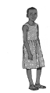

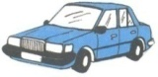Petra



Tina



Rose

**Study the graph and answer the questions**

1. \_\_\_\_\_\_\_ has 3 cars.

2. \_\_\_\_\_\_ and \_\_\_\_\_ have the same number of cars.

3. How many cars are there altogether?

They are 7 cars altogether.

**Activity**

**Study the graph and answer the questions**

|  |  |
| --- | --- |
| Sarah | **SL01040_SL01040_SL01040_** |
| Jane |  |
| Tom |  |
| Peter | **SL01040_SL01040_SL01040_SL01040_SL01040_SL01040_** |

1. Who has 6 balls?

2. \_\_\_\_\_\_ and \_\_\_\_\_\_ have the same number of balls.

**SL01040_SL01040_SL01040_SL01040_**3. \_\_\_\_\_\_ has most balls.

4. Who has the least number of balls?

5. How many balls are there altogether?

**Reference**

**Mk Primary MTCs 2000 book 1 page 86**

**Oxford primary 1 page 67 – 69**

**Understand MTCs Primary 1 page 38**

Fill in the missing numbers

34 =\_\_\_\_\_\_\_tens \_\_\_\_\_\_ ones

56 = 5 tens 6 ones

\_\_\_\_\_tens \_\_\_\_\_ ones

= \_\_\_\_tens \_\_\_\_\_\_ones

**REVISION EXERCISE II**

1. Add:

¾ + ¼ = 1/3 + 1/3 = ½ + 1/2 =

2. Write in words.

a) 41 = \_\_\_\_\_\_\_\_\_\_\_\_\_\_\_\_\_\_ b) 27 = \_\_\_\_\_\_\_\_\_\_\_\_\_\_\_\_\_\_\_\_

c) 60 = \_\_\_\_\_\_\_\_\_\_\_\_\_\_\_\_\_\_\_\_ d) 83 = \_\_\_\_\_\_\_\_\_\_\_\_\_\_\_\_\_\_\_\_

3. Draw and shade the fractions

½ ¼ 1/3

4. What numbers are shown on the abacus?

T O T O T O

**WEEK:**

**CONTENT: REVISION OF END OF YEAR EXAMS**

**REFERENCE: COVERED TOPICS**

**REVISION EXERCISE I**

Add: T O T O 3

7 + 3 = 8 2 2 6 1

10 + 10 = + 1 1 + 3 +6

Take away

9 – 9 = T O T O 1 0

15 – 10 = 2 7 3 8 - 3

1 4 - 4

**Multiply**

3 x 10 = 6 5 2

10 x 2 = x 2 x 3 x 3

Complete the puzzle

\_\_\_\_\_

0

\_\_\_ 2 3 \_\_\_ 2 3 \_\_

7-

1 0 \_ 4

\_\_\_\_ \_\_\_\_ \_\_\_\_\_

**REVISION EXERCISE IV**

Name the edge, face and vertex

2. Comparing objects

a) Peter 1. Who is taller?

Jane 2. Who is shorter?



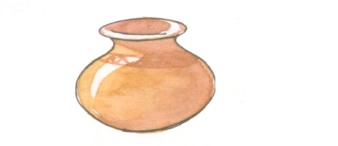b) Pot Cup i) Which one holds more water.

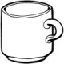 ii) Which one holds less water?

Stick

c) i) Which one is longer?

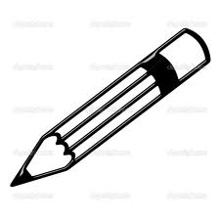 ii) Which one is shorter?

Pencil

d) Which is heavier / lighter?

Stone i) A \_\_\_\_\_ is heavier.

rubber ii) A \_\_\_\_\_ is lighter.

**REVISION EXERCISE V**

Subtract (-)

12 – 8 = T O T O

9 – 9 = 4 9 8 3

1 6 - 2

Draw the sets

A set of balls b) A set of flowers.

Name the sets below.



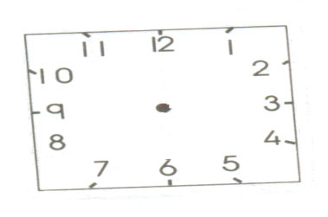Tell the time

It is \_\_\_\_\_\_ O’clock It is \_\_\_\_\_\_\_ O’clock

Fill in the correct time

5 O’clock It is six O’clock

Add using a number line

3 + 4 =

0 1 2 3 4 5 6 7 8 9 10 11 12

7 + 3 =

0 1 2 3 4 5 6 7 8 9 10 11 12

Write the numbers

Fifteen = \_\_\_\_\_\_\_\_\_\_\_\_\_\_\_ Forty five = \_\_\_\_\_\_\_\_\_\_\_\_\_\_\_\_\_

Twenty one = \_\_\_\_\_\_\_\_\_\_\_ thirty = \_\_\_\_\_\_\_\_\_\_\_\_\_\_\_\_\_\_\_\_

Draw the abacus

28 = T O 33 = T O 50 = T O

9. How many legs do 3 boys have?

10. Five cats have \_\_\_\_\_\_\_ ears.

**REVISION EXERCISE**

1. Match the number ordinals well.

first 1st third 3rd

fourth 4th eighth 8th

second 2nd

Write the number figure

Sixteen = \_\_\_\_\_\_\_\_\_ eleventh = \_\_\_\_\_\_\_\_\_

Half = \_\_\_\_\_\_\_\_\_\_\_\_ seventh = \_\_\_\_\_\_\_\_\_\_

a quarter = \_\_\_\_\_\_\_\_ first = \_\_\_\_\_\_\_\_\_\_\_

Name the shapes

Name the curves and lines

SL01040_TREETREESL01040_Form new sets.

Fill in the missing numbers

7 , \_\_ , \_\_ , 4 , \_\_ , 2 , 1 , 0

2 , 4 , \_\_ , 8 , \_\_ , 12

55 , 56 , \_\_\_ , \_\_\_ , 59 , 60

10 , 20 , 30 , \_\_ , \_\_ , 60 , 70 , \_\_\_ , 90

Work out and match

3 + 4 0

3 x 2 7

4 – 4 8

8 + 0 6

Join the sets

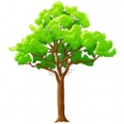

And make



and make

SL01040_SL01040_SL01040_SL01040_SL01040_SL01040_Use less or more B

SL01040_ A

SL01040_

i) Set A has \_\_\_\_\_ balls than set B.

ii) Set B has \_\_\_\_\_\_ balls than set A.

**REVISION EXERCISE VII**

1. What is the middle number?

10, \_\_\_ ,12 21, \_\_\_\_ ,23 45 ,\_\_\_ ,47.

2. What is the number before?

\_\_\_, 2 \_\_\_\_ ,10 \_\_\_\_ ,25 \_\_\_ ,45 \_\_\_\_,47

3. Write the number after?

6, \_\_\_\_ 11,\_\_\_\_ 22, \_\_\_\_\_\_\_ 45, \_\_\_\_

Find the missing numbers.

+ 3 = 5 5 + = = 8

+ - 8 = 2

- 7 = 0

**Word problem**

a) 4 times 3 equals = \_\_\_\_\_\_\_\_

b) How many legs do two tables have?\_\_\_\_\_\_\_\_

c) How many ears do 3 boys have?

**Take away (-)**

d) 10 eggs take away 6 eggs equals \_\_\_\_\_\_\_\_\_

e) Nine take away four equals \_\_\_\_\_\_\_\_\_\_\_\_\_\_\_

f) Adam had 7 cars, he gave away 3 cars. He remained with \_\_\_\_ cars.

**Addition (+)**

g) Five plus three equals to \_\_\_\_\_\_\_\_\_

h) Eight and two make \_\_\_\_\_\_\_\_\_\_\_\_\_

i) Paul has four books. Gift has two books. Altogether they have \_\_ books.

**END**